

“The Complete My One Universe Network Literature”

Introduction, Description, and It Website Parts

Information Technology Database

Developed by

James L. Avakian, Engineering Technologist

Lead MERN Software Developer

Optical Automation, LLC

Thirteen pages, Website Version available

http://www.MyOneUniverse.com

Written By James L. Avakian, Developer

Optical Automation, LLC
Technology Documentation
Software Product Division
5065 Amigo Avenue
Tarzana, CA 91356
Table Of Contents
Page

I. Table Of Contents . . . . . . . . . . . . . . . . . . . . . . . . . . . . . . . . . . . i

II. Product Introduction . . . . . . . . . . . . . . . . . . . . . . . . . . . . . . . . . . . 1

III. Network Technology and Authentication
A. The Programming . . . . . . . . . . . . . . . . . . . . . . . . . . . . . . . . . . . . . . . . . . 2
B. Responsive Design . . . . . . . . . . . . . . . . . . . . . . . . . . . . . . . . . . . . . . . . . . 3
C. Authorization, Security . . . . . . . . . . . . . . . . . . . . . . . . . . . . . . . . . . . . . . . . . . 6
D. Authentication, Security . . . . . . . . . . . . . . . . . . . . . . . . . . . . . . . . . . . . . . . . . . 7
E. JWT Security . . . . . . . . . . . . . . . . . . . . . . . . . . . . . . . . . . . . . . . . . . 8
F. PostHog . . . . . . . . . . . . . . . . . . . . . . . . . . . . . . . . . . . . . . . . . . 8

V. Display Access
A. App Applications . . . . . . . . . . . . . . . . . . . . . . . . . . . . . . . . . . . . . . . . . . 8
B. Your Dashboard . . . . . . . . . . . . . . . . . . . . . . . . . . . . . . . . . . . . . . . . . . 8
C. Administrator . . . . . . . . . . . . . . . . . . . . . . . . . . . . . . . . . . . . . . . . . . 8
D. Dashboard . . . . . . . . . . . . . . . . . . . . . . . . . . . . . . . . . . . . . . . . . . 8

VI. Pricing
A. Client . . . . . . . . . . . . . . . . . . . . . . . . . . . . . . . . . . . . . . . . . . 9
B. Administrator . . . . . . . . . . . . . . . . . . . . . . . . . . . . . . . . . . . . . . . . . . 9

VII. Conclusiion . . . . . . . . . . . . . . . . . . . . . . . . . . . . . . . . . . . 9

VIII. The Developer, Author . . . . . . . . . . . . . . . . . . . . . . . . . . . . . . . . . . .

The Appendixes

Appendix A – The Complete MyOneUniverse 10

Appendix B – Company and Product Videos 11

Appendix C – Other Social Media Networks 12

Appendix D – Legal Disclosure 13

Page One
Introduction

My One Universe has both private and public Internet areas. The online social media area is American technology first created by James L. Avakian in 2020 as a place to store details such as lists. We coined the icon and website known as the ShopperLady(r) part of our MyList Network website. The network has several sections and is in “beta” test application use at this time. A reference website is AmericaDiscovered that discusses this country and what life is like.

The network was designed to equally be displayed on a computer, laptop, tablet, and cellphone without the need for a separate app from an app store. The best viewing experience is from a computer in full screen mode.

Unlike Facebook, Twitter, and Instagram, our new network is a novelty and a startup information technology product.

MyOneUniverse is our network, it is comprised of the following Internet Domains and description:

MyList Network.com List Creators
AmericaDiscovered.com An American Reference
MyEntertainmentWeb.com Your Entertainment Information
MyPersonalOrganizer.com Detail Organizer, Photos, and Editor
MyTechnologyHouse.com Portfolio Web

My1Apps.com Your Dashboard App Center

My One Universe is the network home page and marketing information describing network content and how to access your information. This is the first place the public and clients land to learn about this network and its access and related costs. The websites are like islands or planets in our network universe. So look, learn, and have fun!

MyList Network.com is represented by ShopperLady and ShopperLady Today websites. The basic premise create lists of food, drugstore, office, hardware, and garden. Additional plans include more detailed information for automotive maintenance, beauty supply, and clothes buying for men, women, and kids.

AmericaDiscovered.com is a website of life in America. Sections include the government, states, and counties. Medicine, insurance, and more and where to buy it. America invented the fast food industries of American, Chinese, Italian, and more.

MyEntertainmentWeb.com is your entertainment center ! Information relating to movies and television and also Internet games. We strive for your entertainment because many people need instant actor and actress information.

MyPersonalOrganizer.com is you place to organize details ! Your monthly expenses, your business. Lyrics, documents, and hobby details can be stored here

MyTechnologyHouse.com is composed of OpticalAutomation portfolio products such as the following:
HouseOfWebs.com, TechnologyAndTimes.com, and TheBrandedSeries.com groups of websites we made over the past decade.

My1Apps.com is your special place for network information. Its all about the network! It shows your usage, where you store information, when you stored and updated information. Your single reference ! Emergency information displayed here, with your permission, your doctors and physicians are listed for first responder access to help you recover from accident. Great for any age, young and old.

Page Two

- Network Technology and Authentication

A. The Programming

Developed with a Full Stack front-end and back-end software set of technologies. It is a genuine MERN stack, we programmed it with MongoDB, ExpressJS, ReactJS, and NodeJS technologies. It even includes Mongoose, CORS, Nodemon and more under the software complier hood.

The database is a durable internet accessible database with the latest security in place. Use of Auth0 is a client server access to allow its client secure access. Our software LogView accounts for accesses, both information updates and displays. We know when clients are using our database and how much.

Network Technology

Introduction, The Mongo Stack

Front End technologies are the website and framework and composed of ReactJS.

Back End technologies are the database as a datasource. This includes the MongoDB, ExpressJS, ExpressJS, ReactJS, and NodeJS

ReactJS, Front End Technology

The entire website uses industry standard ReactJS and is the Front End programming.

It was released first in 2013, and since then, it has become one of the most popular JavaScript libraries for building user interfaces. A Facebook innovation, it was developed by Jordan Walke, a software engineer and was initially released as an open-source project on GitHub.

Reprinted, Wikipedia, ReactJS

ClassNames in the ReactJS, JSX, are the webpage formatting, all the objects, text, images, and media are located by a format supplied by CSS3 and TailwindCSS, inside the ReactJS JSX pages CSS selectors are “classNames” that are named in .css files to specifically format each.

The industry standard location we store files are in Github.

This Front End technology called full-stack website programming.

MERN Stack, Back End Technology

The MERN Stack is a collection of technologies used to develop web applications. It was developed by Facebook back in 2013. It is an information technology industry standard. MERN is an acronym for the four technologies used: MongoDB, ExpressJS, React, and NodeJS.

Page Three

MongoDB is a product from the MongoDB company in United Kingdom, It is an industry standard everywhere.

ExpressJS was invented in April 2010 by TJ Holowaychuk, StrongLoop and others.

NodeJS was written initially by Ryan Dahl in 2009, about thirteen years after the introduction of the first server-side JavaScript environment, Netscape's LiveWire Pro Web. The initial release supported only Linux and Mac OS X. Its development and maintenance was led by Dahl and later sponsored by Joyent. The collection known as MERN aims to make the development process easier and smoother.

Reprinted, Google browser search, MERN Stack, Express.js, and Node.js

Mongoose is MERN middleware. It defines how the data is stored to and from the website into MongoDB by a “Schema”. Axios is a connector to fetch data from a URL database by an Application Programming Interface, API, for public data access.

B. Responsive Design

From my past five years of Full Stack website development, I used CSS3, TailwindCSS, and others. These are industry standard programming script programming languages and they strictly locate, position, and format all of the text, images, and video on each page of the screen. These scripting posotoins everything on a page and without both abstract and difficult reading could be maintained. Thus due to script industry standard and practice, I use these daily in my programing coding practice.

Because I first learned ReactJS three years ago using CSS3, I have found a close passion for its use. Each 'class' element can be defined exactly as the programmer dictates as with html page coding. In the case of MERN programming, the “R” stands for ReactJS and maintains use of “classNames” as selectors in the .css files as direct connection between the JSX ReactJS page and specific .CSS pages.

Flex, a Industry Magician

A programing method called Flexbox and Grid are similar but different in programming methods. Due to my first learning Flexbox I perfer to use it over Grid, but can read both.

Definition

CSS flexbox layout explains everything about all the different possible properties for the parent element (the flex container) and the child elements (the flex items).

Reprinted From, “CSS-Tricks”

Like an electronics schematic or architectural blueprint, CSS are the backbone of a website webpage. Whether the information displayed is from a dynamic database datasource or a statically placed set of words or paragraph, it is the work of CSS that arranges where data, numbers, and media and its place on a website webpage.

The Technology

A Responsive website Design Website, is provided by a programmer using CSS3. It automatically adjusts a display output equally to any size display. We use CSS3 Media Query for this programming. Whether the display is a full size 70” computer monitor, 15” laptop, Tablet, or Cellphone computer. A single set of programming accommodates all of these display sizes by itself. Its self-contained programming provides for all information display equally on the screen.

Page Four
“The Importance Of Responsive Website Development”

Computer, full size 1200 x 2400
Laptop, Full Size 800 x 1200
Tablet, Handheld 600 x 800
Cellphone, Handheld 320 x 480 pixels

Figure One – Full Size, 1200 x 2400

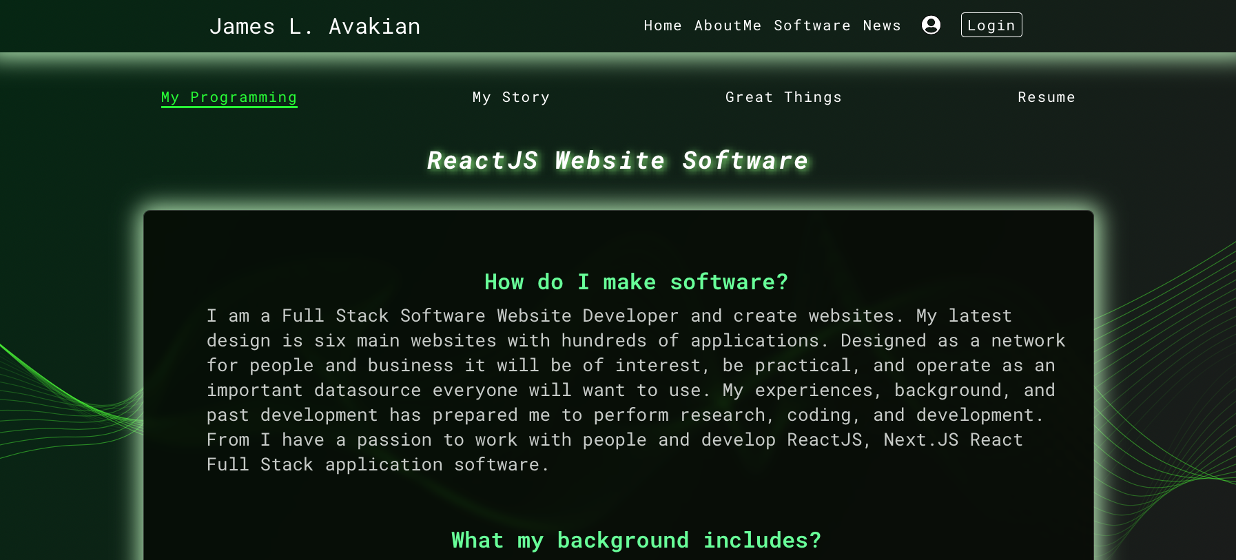
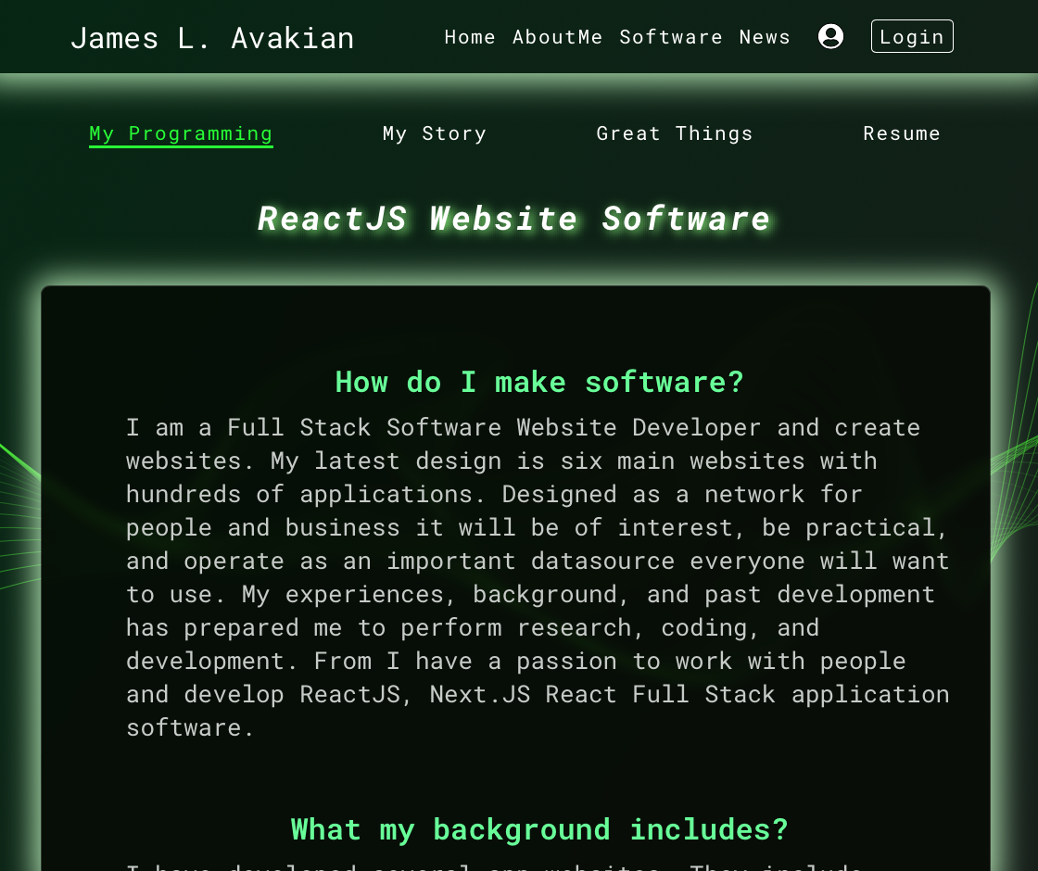
Figure Two – Middle Size, 600 x 800

Page Five
Figure Three – Small Size, 230 x 320

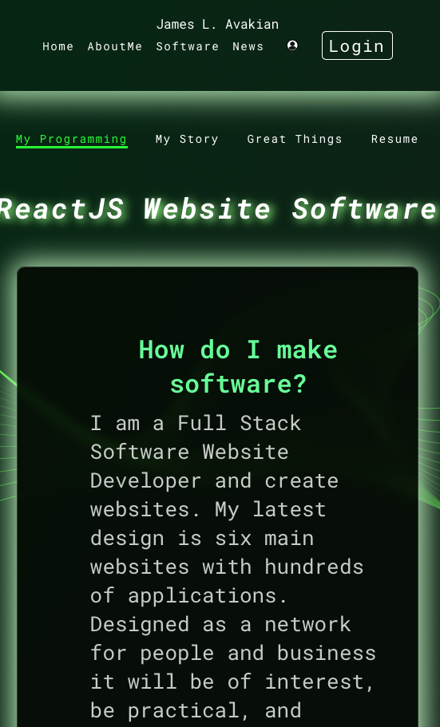

Responsive Website Design provides for controlling all the parts of the website at Full, Middle, and Small sized displays as shown in Figure One, Two, and Three above. The information is specified by the CSS3 media query selector and adjustable by programming, size, and color. The main idea here is that you only need one set of code by the programmer and no need for a separate app application in an App Store. The cost is half and the time is the same for all website presentations.

A website is compiled for processing display. The programmer and computer compiler checks for errors and proper language implementation. Then the programmer deploys a Build of the website output so an Internet hosting computer can display it. The programmer next assigns a paid Internet Domain Name to the deployed website name. The end user client enters the http://www.DomainName.com and the website is shown by any of the devices. Although we discussed all displays, Watch, display are not covered and are way too small, but if a database is deploy the information stored may be displayed by a Watch with corresponding software.

Page Six

Network Security, Authorization and Authentication

Authentication
Authentication and authorization are two vital information security processes that administrators use to protect systems and information. Authentication verifies the identity of a user or service, and authorization determines their access rights.

Authentication is the act of validating that users are whom they claim to be. This is the first step in any security process.
Reprinted from okta.com

An authentication complete process with:
Passwords. Usernames and passwords are the most common authentication factors. If a user enters the correct data, the system assumes the identity is valid and grants access.
One-time pins. Grant access for only one session or transaction.
Authentication apps. Generate security codes via an outside party that grants access.
Biometrics. A user presents a fingerprint or eye scan to gain access to the system.
In some instances, systems require the successful verification of more than one factor before granting access. This multi-factor authentication (MFA) requirement is often deployed to increase security beyond what passwords alone can provide. (This network does not utilize finger or eye scanning).

Authorization

Authorization in system security is the process of giving the user permission to access a specific resource or function. This term is often used interchangeably with access control or client privilege.
Reprinted from okta.com
Giving someone permission to download a particular file on a server or providing individual users with administrative access to an application are good examples of authorization. In secure environments, authorization must always follow authentication. Users should first prove that their identities are genuine before an organization’s administrators grant them access to the requested resources.

Authentication vs. Authorization
Despite the similar-sounding terms, authentication and authorization are separate steps in the login process. Understanding the difference between the two is key to successfully implementing an IAM solution.
Let's use an analogy to outline the differences. Consider a person walking up to a locked door to provide care to a pet while the family is away on vacation. That person needs:
Page Seven
Authentication, in the form of a key. The lock on the door only grants access to someone with the correct key in much the same way that a system only grants access to users who have the correct credentials.

Authorization, in the form of permissions. Once inside, the person has the authorization to access the kitchen and open the cupboard that holds the pet food. The person may not have permission to go into the bedroom for a quick nap.

Authentication and authorization work together in this example. A pet sitter has the right to enter the house (authentication), and once there, they have access to certain areas (authorization).

Table One – Comparisons to Authentication and Authorization

Authentication Authorization

What does it do ? Verifies credentials Grants or denies
permissions

How does it work ? Through passwords or Through settings
Apps maintained by security
administrator

Visible to the users ? Yes No

Changeable by user ? Partially No

How does data move ? Through ID tokens Through access tokens

E. JWT Security .

Java Writing Tokens. JWT, are tokens that are the tiny building blocks of a Java program thata are meaningful to the Java compiler. Tokens are the basic building blocks of any code script. These include keywords, operators, constants, or others unique syntactic stuff specfic to the language

Reprinted from Google, March 23, 2023

JSON Web Token (JWT) is an open standard (RFC 7519) that defines a compact and self-contained way for securely transmitting information between parties as a JSON object. This information can be verified and trusted because it is digitally signed. JWTs can be signed using a secret (with the HMAC algorithm) or a public/private key pair using RSA.

Reprinted from JWT.io

Page Eight

A JSON Web Token is used to carry information related to the identity and characteristics (claims) of a client. This information is signed by the server in order for it to detect whether it was tampered with after sending it to the client. This will prevent an attacker from changing the identity or any characteristics (for example, changing the role from simple user to admin or change the client login).

This token is created during authentication (is provided in case of successful authentication) and is verified by the server before any processing. It is used by an application to allow a client to present a token representing the user's "identity card" to the server and allow the server to verify the validity and integrity of the token in a secure way, all of this in a stateless and portable approach (portable in the way that client and server technologies can be different including also the transport channel even if HTTP is the most often used).

F. PostHog

PostHog is a product of analytics & experimentation as an all in one platform. Get started. Improve your product with analytics, session recording, heatmaps, feature flags, & more. Heatmaps. Feature Flags. Product Experimentation. Session Recording & More.

This is a accounting method for verification of data storage and access. This assists as a legal tool for data access according to client information loss or valid information access.

- Display Access

A. App Applications

The Apps are the center of each website. They both entertain, act as tools, and an asset to the network. We sell the apps, some are free and others are paid. Both are listed on the dashboard.

B. Your Dashboard

The Dashboard displays App ownership, network usage, clients in the public network and more. The dashboard shows a record of what parts of the network you use and how long and when. Also a record of where you access and update your personal information is displayed. There is no cost for used of your Dashboard.

C. Administrator

Administrator access is not to be discussed because the network runs with one to two years of employed man hours, from two years employment. The rate to employ an engineer is one hundred thousand dollars plus worker compensation insurance plus legal fees. This includes U.S. Copyright. It is your staff and programming to could present patent applications based on the system add to our system of code at the date of purchase. Therefore there is no Administer access available for purchase at this time.

D. Administrator Dashboard

No access at this time, it is solely an Optical Automation product at this time.

Page Nine
E. Advertising

Certain parts of our network is “ad-free” no advertising so you can focus on your own entertainment. Because we are trying to make the network a commercial public place everyone can enjoy we need front page advertising so we can generate revenue from your viewing. We will not show ads inside app applications. We only show advertising on the first pages and on the marketing descriptions so you can benefit from online Internet marketing and our creative app applications.

- Pricing

A. Client

The App Applications are a dollar each and full website access priced at five dollars a month. Full network access it available at twenty-five dollars. Access to the Dashboard is free because it is a record of your purchases and where you enter data.

B. Administrator

None available.

Conclusion

Although words can describe many things from my creative thoughts, but the network is composed of several websites. Internet websites are visual, interactive, and provoke action, thus I cannot say enough about these works of programming creativity, they just must experienced first hand in a browser on your computer, tablet, or cellphone to capture the interest of these database information technology greatness.

The MyOneUniverse network is composed of many general applications. Specifically it can be described as interactive and interesting. Overall the following is what the MyOneUniverse does and where the parts are located:

MyList Network.com List Creators
AmericaDiscovered.com An American Reference
MyEntertainmentWeb.com Your Entertainment Information
MyPersonalOrganizer.com Detail Organizer, Photos, and Editor
MyTechnologyHouse.com Portfolio Web

Visit the network and its parts often, its information is updated and changing everyday by our staff.

Thank you,

James L. Avakian, Developer
Optical Automation, LLC

Page Ten
Appendix A

The Complete My One Universe Network

Optical Automation http://www.OpticalAutomation.com
MyOneUniverse http://www.MyOneUniverse.com
MyOneUniverse, Access Store http://www.MyOneUniverse.shop
MyListNetwork http://www.MyListNetwork.com
The ShopperLady http://www.ShopperLady.com
ShopperLady Today http://www.ShopperLadyToday.com
My Entertainment Web http://www.MyEntertainmentWeb.com
America Discovered http://www.AmericaDiscovered.com
Network Dashboard http://www.My1apps.com
MyPersonalOrganizer http://www.MyPersonalOrganizer.com
DetailBase http://www.DetailBase.com
MyTechnologyHouse http://www.MyTechnologyHoues.com
CoolJimmy.com
HouseOfWebs.com,
DollarDiscount.com,
Technology And Times.com and
TheBrandedSeries.com
Network Author http://www.James Avakian.com

Page Eleven
Appendix B- Product Videos

Pinterest index
https://www.pinterest.com/jamesavakian/my-product-videos/
Optical Automation
https://biteable.com/watch/3035980/b7b7c1a2ea14509b9b6e152036949f15
Optical Automation, Mission Statement 2023
https://biteable.com/watch/3036644/5d5e973fde30a409cd59ec9ec36ee406
Author, James L. Avakian
https://biteable.com/watch/3261325/ac1ef537457524ade58bc73cfe4c7a72
Developer, James L. Avakian
https://biteable.com/watch/3714125/a539e52ce6ef052bf12e4ce7deb2d60e
MyOneUniverse, Videos
https://biteable.com/watch/3097407/594a720b62bae68b534951d25eb0dbd3
AmericanaDiscovered
https://biteable.com/watch/3081382/4ca1b6f98216d3de312e043e19c7e477
ShopperLady
https://biteable.com/watch/3036301/9daa88c0c742444f8edb2a1fd4961fdf
PersonalOrganizer
https://biteable.com/watch/3036416/d13a69fe6ecd6b46d67bfbf36500ceb4
BusinessOrganizer
https://biteable.com/watch/3039291/459a747027c6b92a0e5b3ca30f1ce2d2
My Technology House
https://biteable.com/watch/3041713/2d4fb91f031c4c0a1344f4456c9204e5
Technology and Times
https://biteable.com/watch/3041599/7951c6d469fd16c1f488856b2da18915

Page Tweleve
Appendix C
Social Media Networks

GitHub Repository,
https://www.github.com/jamesvakian62
One Github Repository,
https://www.github.com/javakian
Facebook
https://www.Facebook.com/james.avakian.9
LinkedIn
https://www.LinkedIn.com/in/james-l-avakian-13500713/
Pinterest
https://www.Pinterest.com/jamesavakian/_saved/
INstagram
https://www.Instagram.com/jamesavakian/
StackShare
https://stackshare.io/jamesavakian62/jamesavakian62#stack

Page Thirteen

Appendix D

Legal Disclosure

- All company icons and names mentioned in this website technical document are property owership of Optical Automation, LLC. Optical Automation, name text and artwork logo are registered with the United States Patent and Trademark.
- Internet domain names have been paid and illustrated by this documentant website are registered by registrar Internet domain name registrations as property of Optical Automation, LLC.
- The names OpticalAutomation,OpticalAutomation icon,ShopperLady,and ShopperLady icon has been registered by the U.S. Trademark Office and property of Optical Automation, LLC, A California Corporation.
- All other industry technologies and product names are ownership ofe ach respective company.

